108 Sun Salutations Challenge
In honour of Trish Sorrell our yoga friend from Hathersage.
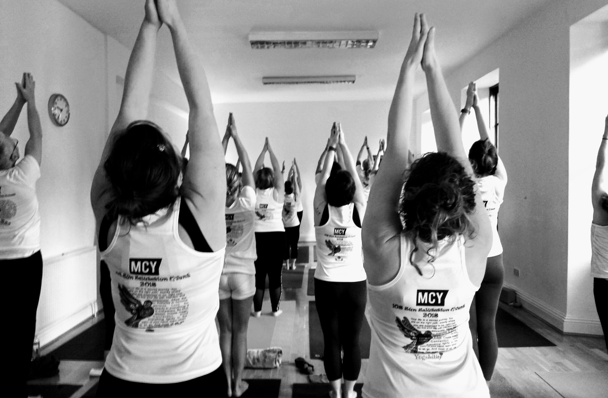

We invite you to join us on
Saturday 2nd November 2019
at Hathersage Memorial Hall 10am - 1pm
to undertake our 108 Sun Salutations Challenge.
This is a Charity event with all the proceeds to Weston Park hospital Sheffield .

108 Sun Salutations – an auspicious number in Yogic tradition and is considered a sacred number in hinduism and yoga, because of the 108 sacred points in the body (ayurveda), mala beads have 108 beads (used in meditation) and the Earth is roughly 108 times the sun diameter.

This event is opened to all, regardless of yoga experience or practice. Fiona Johnston will lead this refreshing mildly dynamic practice ending with a lovely long relaxation. Sun Salutation is suitable for everybody and energises the whole body and calm the mind as well.

Suggested donation £15 per participant
and there are sponsorship forms, attached, should you wish to request this.

Home made cakes and yogi tea will be served, all proceeds to charity.

